
Transformation, Communities & Corporate Services

Falkirk Council

Pension Fund

Risk Management Policy

Local Government Pension Scheme

14 March 2024

Version Control

Version | Date of Change | Last Committee/Board  Approval Date | Comment
1.0 | 1 November 2018 | 21 March 2019 | Document created following External Audit recommendation in 2017/18 Annual Audit to update risk register.
1.1 | 1 March 2024 | 14 March 2024 | Policy reviewed and revised March 2024.

Falkirk Council Pension Fund
Risk Management Policy

- Introduction

1.1 This document sets out the Risk Management Policy for Falkirk Council Pension Fund (“the Fund”).

1.2 The Fund is part of the Local Government Pension Scheme (Scotland) and is managed and administered by Falkirk Council ("the Administering Authority"). The Council has delegated responsibility for Fund matters to a Pensions Committee. The Committee is the decision-making body of the Fund and is drawn mainly from Falkirk Council’s elected members but includes member, pensioner and employer representatives. The Committee is supported in its role by the statutory Pension Board which consists of an equal number of member and employer representatives.

1.3 In the rest of this document, references to “the Fund” include those charged with the governance of the Fund - the Pensions Committee, Pension Board and senior officers.

1.4 The Risk Management Policy details the risk management strategy for the Fund, including:

- the risk philosophy for the management of the Fund, and in particular attitudes to, and appetite for, risk
- how risk management is implemented
- risk management responsibilities
- the procedures that are adopted in the Fund's risk management process
- the key internal controls

1.5 The Fund recognises that effective risk management is an essential element of good governance in the Local Government Pension Scheme. By identifying and managing risks through an effective policy and risk management strategy, the Fund can:

- demonstrate best practice in governance
- improve financial management
- minimise the risk and effect of adverse conditions
- minimise threats

1.6 The Fund adopts a structured and focused approach to managing risks and ensures risk management is an integral part in the governance of the Fund at both a strategic and operational level.

- To whom this Policy Applies

2.1 This Risk Management Policy applies to all members of the Pensions Committee and the Pension Board. It also applies to senior officers involved in the management of the Fund.

2.2 All members of staff involved in the daily management of the Fund are also integral to managing risk for the Fund and will be required to have appropriate understanding of risk management in the context of their roles.

2.3 Advisers and suppliers to the Fund are also expected to be aware of this Policy, and assist officers, Committee members and Board members as required, in meeting the objectives of this Policy.

3. Aims and Objectives

3.1 In relation to understanding and monitoring risk, the Fund aims to:

- integrate risk management into its culture and day-to-day activities
- raise awareness of the need for risk management by all those connected with the management of the Fund (including advisers, employers and other partners)
- anticipate and respond positively to change
- minimise the probability of negative outcomes for the Fund and its stakeholders
- have a robust framework for the identification, analysis, assessment and management of risk.

3.2 These aims and objectives are consistent with the Pensions Regulator's General Code of Practice module on risk.

- Risk Management Philosophy

4.1 The Fund recognises that it is not possible to eliminate all risks. Accepting and actively managing risk is, therefore, a key part of the risk management strategy for the Fund.

4.2 A key determinant in selecting the action to be taken in relation to any risk will be its potential impact on the Fund’s objectives and the Fund’s appetite for risk, particularly in relation to investment matters. Equally important is striking a balance between the cost of risk control actions against the possible effect of the risk occurring.

4.3 In managing risk, the Fund will:

- adopt a system that will enable the Fund to anticipate and respond to change
- minimise loss and damage to the Fund and to other stakeholders who are dependent on the benefits and services provided
- ensure that new areas of activity (e.g. new investment strategies) are only undertaken if the risks are understood and have been included in the decision- making

4.4 The Fund considers that risk management is an essential part of its stewardship, with the benefits being better decision-making, improved performance and service delivery, more effective use of resources and protection from reputational damage.

- The Pensions Regulator's General Code of Practice

5.1 Under the risk management module of the Regulator’s General Code of Practice, the scheme manager of a public service pension scheme must establish and operate internal controls. The controls should be adequate to ensure that the scheme is administered and managed in accordance with the scheme rules and legal requirements. The controls should include the clear separation of duties, processes for escalating concerns, as well as documented procedures for assessing and managing risk, reviewing breaches of law and managing contributions to the Fund.

5.2 For these purposes, ‘internal controls’ mean:
- arrangements and procedures to be followed in the administration and management of the scheme
- systems and arrangements for monitoring that administration and management, and
- arrangements and procedures for the safe custody/security of Fund assets

5.3 The guidance on internal controls goes on to say that scheme managers should carry out a risk assessment and produce a risk register which is reviewed regularly. The risk assessment should be cognisant of:

- the objectives of the Fund
- the various functions and activities carried out in the running of the scheme, and
- identifying the main risks associated with those objectives, functions and activities

5.4 The code of practice states that schemes should consider the likelihood of risks arising and their effect if they do arise when determining the order of priority for managing risks, and focus on those areas where the impact and likelihood of a risk materialising is high. Schemes should then consider what internal controls are appropriate to mitigate the main risks they have identified and how best to monitor them. The code includes the following examples as matters which Funds should consider when designing internal controls to manage risks:

- how the control is to be implemented and the skills of the person performing the control
- the level of reliance that can be placed on information technology solutions where processes are automated
- whether a control is capable of preventing future recurrence or merely detecting an event that has already happened
- the frequency and timeliness of a control process
- how the control will ensure that data is managed securely, and
- the process for flagging errors or control failures, and approval and authorisation controls.

5.5 The code states that risk assessment is a continual process and should take account of a changing environment and new and emerging risks. The adequacy of internal controls should be reviewed on a regular basis.

5.6 Under section 13 of the Pensions Act 2004, the Pensions Regulator can issue an improvement notice (i.e. a notice requiring steps to be taken to rectify a situation) where it is considered that the requirements relating to internal controls are not being adhered to.

- Application to the Falkirk Council Pension Fund

6.1 The Fund acknowledges the need to comply with the Pension Regulator’s General Code of Practice when managing risk. This Risk Management Policy highlights how the Fund strives to achieve this through using of risk management processes and internal controls incorporating regular monitoring and reporting.

- Responsibility

7.1 The Fund must be satisfied that risks are appropriately managed. For this purpose, the Chief Finance Officer is the designated individual for ensuring the process outlined below is carried out, subject to the oversight of the Pensions Committee and Pension Board.

7.2 However, it is the responsibility of each individual covered by this Policy to identify any potential risks for the Fund and ensure that they are fed into the risk management process.

- The Fund Risk Management Process

8.1 The Fund’s risk management process is in line with that recommended by CIPFA and is a continuous approach which looks at risks surrounding the Fund’s past, present and future activities. The main processes involved in risk management are identified in the virtuous circle below and detailed in the following sections:

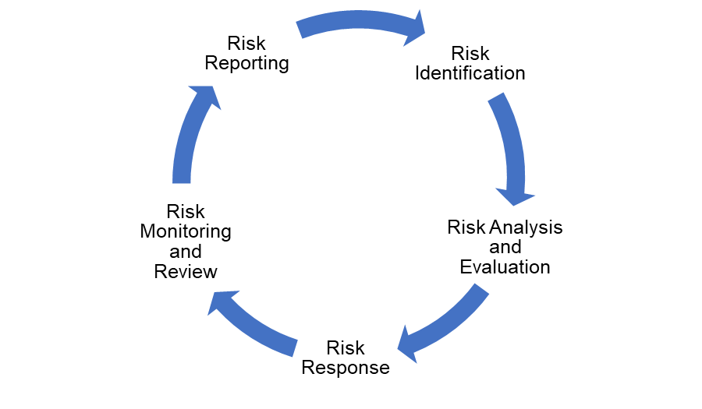
Risk Identification

8.2 The risk identification process is both forward and backwards looking. Forward looking to scan the horizon for potential risks and backwards looking to learn lessons from previous circumstances which created risks for the Fund.

8.3 Risks are identified by a number of means such as:

- performance measurement against agreed objectives
- findings of internal and external audit and other adviser reports
- feedback from the local Pension Board, employers and other stakeholders
- knowledge, observations and experiences of senior officers or other staff involved in the management of the Fund
- liaison with other organisations, national associations, professional groups, etc.

8.4 Once identified, risks will be documented on the Fund's risk register, which is the primary control document for the subsequent analysis and monitoring of those risks.

Risk Analysis & Evaluation

8.5 Once potential risks have been identified, the next stage of the process is to analyse and profile each risk. Risks will be assessed by considering the likelihood of the risk occurring and the impact if it does occur. Likelihood is on a scale of 1 to 4 with one being rare and four almost certain. Impact is also assessed on a scale of 1 to 4 with one being insignificant and 4 being severe.

8.6 The score for likelihood is multiplied by the score for impact to determine a gross overall risk rating (i.e. before the application of any mitigations). From the scores, a risk matrix can be constructed (as illustrated below) which allows risks to be categorised into four bands – Low, Medium, High and Very High.

 |  | Impact
 |  | Minor  1 | Moderate  2 | Major  3 | Critical  4
Likelihood | Unlikely 1 | Low (1) | Low (2) | Low (3) | Medium (4)
Likelihood | Possible 2 | Low (2) | Medium (4) | Medium (6) | High (8)
Likelihood | Probable 3 | Low (3) | Medium (6) | High (9) | Very High (12)
Likelihood | Almost 4  Certain | Medium (4) | High (8) | Very High (12) | Very High (16)

Risk Response

8.7 The risk response is essentially an expression of the Fund’s attitude to the different levels of risk identified.

8.8 Due to its fiduciary duty, the Fund has a cautious attitude to risk, particularly in relation to investment matters. The Fund will, therefore, look to implement options that have a strong control framework which is proportionate to the size, nature, scale, and complexity of the activities of the scheme and which results in low residual risk.

8.9 The Fund will, however, take risks that have been carefully considered and where controls have been implemented to reduce the likelihood of a risk materialising or the impact if one did materialise.
8.10 The Fund will also seek to apply controls and actions (i.e. mitigations) to reduce the likelihood of a risk occurring or minimise the impact of the risk if it does occur. The level of risk which remains after taking account of any mitigations is classified as the net risk.

8.11 In terms of the four bands of risk previously identified, the Fund’s approach to combating these is as follows:

Level of Net Risk | Consequences
Low 1 - 3 | Fund considers this level of risk tolerable
Medium 4 - 6 | Fund expects this level of risk to be contained with minimal intervention
High 7 - 9 | Fund is concerned about this type of risk and looks to manage it through mitigation and action plans
Very High 10 - 16 | Fund is very concerned with this type of risk and looks to eliminate or contain it through a combination of contingencies, mitigations and short term action plans

Risk Monitoring & Review

8.12 Risk monitoring is the final part of the risk management cycle and is the responsibility of the Pensions Committee and Pension Board.

8.13 In monitoring risk management activity, the Committee and Board should consider whether:

▪ the risk controls taken achieved the desired outcomes
▪ the procedures adopted for undertaking the risk assessment were appropriate
▪ there are any lessons to be learned for the future assessment and management of risks.

8.14 The Chief Finance Officer will review the extent to which the identified risks are covered by existing internal controls and determine whether any further action is required to control the risk, including reducing the likelihood of a risk event occurring or reducing the severity of the consequences should it occur.

Risk Reporting

8.15 The Fund's risk register details all relevant information in relation to a risk as well as the owner for any actions.

8.16 To protect the Fund from targeted adverse activity, such as cyber attack, the register will not be available for public inspection but will be brought to the Committee for approval at least annually.

8.17 The Pensions Committee and Pension Board will be provided with updates on a quarterly basis in relation to any heightened areas of risk or newly identified risks.

8.18 As a matter of course, all staff members monitor risk on a daily basis. In addition, senior officers in the Fund will meet at least once a year to review the risk register. The Chair of the Pension Board will be invited to these meetings.

8.19 Where a risk is identified that could be of significance to Falkirk Council, the Chief Finance Officer should request that it be included in the Corporate Risk Register.

- Key risks to the effective delivery of this Policy

9.1 The key risks to the delivery of this Policy are outlined below:

- Changes in Pension Committee and/or local Pension Board membership and/or senior officers mean key risks are not identified due to lack of knowledge
- Insufficient resources are available to satisfactorily assess or take appropriate action in relation to identified risks
- Risks are incorrectly assessed due to a lack of knowledge or understanding, leading to inappropriate levels of risk being taken without proper controls
- Lack of engagement or awareness of external factors means key risks are not identified
- Conflicts of interest or other factors lead to a failure to identify or assess risks appropriately

9.2 The Pension Committee will monitor these and other key risks and consider how to respond to them.

- Costs

  - All costs related to this Risk Policy are met directly by the Fund.

- Approval, Review and Consultation

This Risk Management Policy was approved at the Falkirk Council Pension Committee meeting on 14 March 2024. It will be formally reviewed and updated at least every three years or sooner should there be material changes to Fund’s risk management arrangements.

Chief Finance Officer
Falkirk Council

14 March 2024

